CALL FOR SUBMISSIONS:
Community engagement for inclusive rural transformation and gender equality
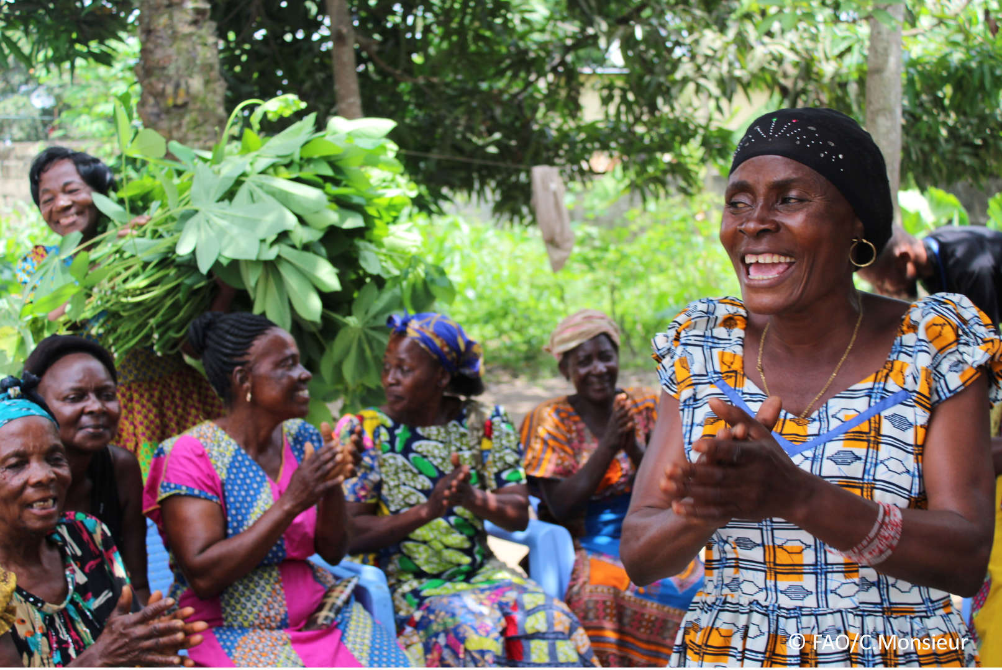
The objective of this call for submissions is to collect good practices, experiences, and lessons learnt on the use of community engagement for inclusive rural transformation and gender equality. The initiative, organized by the Rural Transformation and Gender Equality Division (ESP), seeks to gather insights from a diverse range of contributors, both within FAO and from external stakeholders. Its goal is to share knowledge, foster learning, and guide the scaling up of community engagement and community-led collective action to leave no one behind. The call builds on FAO's past efforts in this area, such as the Community Engagement Days series of webinars.
The call for submissions is open until 27 November 2024.

How to take part in this call for submissions:
To take part in this Call for submissions, please register to the FSN Forum, if you are not yet a member, or “sign in” to your account. Please review the topic note to understand the criteria we are considering for this call. If you wish to learn more about community engagement, you may refer to the background document. Once you have completed this submission template, upload it in the box “Post your contribution” on the call webpage, or, alternatively, send it to fsn-moderator@fao.org.
Please keep the length of submissions limited to 1,500 words and feel also free to attach relevant supporting materials.

Template for submissions

Contact person | Name: Henry W.Singili  Organization/Unit: Movimento Mocambicano de Mulheres Rurais  Country: Mozambique  Email address: hwsingili@yahoo.co.uk
Name/title of the good practice | Transitioning smallholder farmers to agroecology: A community engagement
Where is the good practice taking place? (Multiple selection allowed) | ☐ Europe and Central Asia  ☐ Latin America and the Caribbean  ☐ North Africa and Near East  ☒ Sub-Saharan Africa  ☐ Asia and the Pacific  ☐ North America  ☐ Global
Affiliation | ☐ Farmer and producer organizations  ☐ Trade Union  ☐ Informal community-based, farmer-based or self-help group  ☐ Research and academia  ☐ Government  ☐ Local/traditional authorities  ☐ Private Sector  ☒ Civil Society Organization  ☐ Intergovernmental Organization (e.g. UN system, World Bank)  ☐ Resource Partner/Donor  ☐ Other (please specify)
In which sector(s) and context (s) have you used this community engagement good practice? (Multiple selections allowed) | ☐ Education  ☐ Health and Sanitation  ☒ Food production in agrifood systems (please also tick the sub-categories)  ☒ Crop cultivation  ☒ Fisheries and aquaculture production  ☐ Livestock  ☒ Forestry  ☒ Agroforestry  ☒ Horticulture  ☐ Apiculture (beekeeping)  ☒ Agroecology and sustainable farming practices  ☐ Soil and water management  ☐ Other: ____________  ☒ Post-production in agrifood systems (please also tick the sub-categories)  ☒ Processing and value addition  ☐ Marketing and retailing  ☐ Transporting  ☒ Food loss and waste  ☐ Packaging  ☒ Storage  ☐ Distribution  ☐ Other _________  ☒ Gender Equality  ☒ Climate Action  ☒ Citizenship and Governance  ☐ Social Protection  ☐ Humanitarian and protracted crisis  ☐ Conflict resolution, peace and resilience  ☐ Digital innovation  ☐ Other sector (please specify) _________
Who are the financial partners supporting this good practice, if applicable? | Agroecological Fund (AEF) and Bread for the World (BftW)
- In a few sentences, summarize your community engagement good practice.
The community engagement started with community mobilization and the holding of community interface meeting that brought all the stakeholders in the community that included smallholder farmers (women, men and the youth), government officials, local councillors, member of parliament, agro-dealers, traditional and community leaders ,CSOs and the media, to familiarize community members on the need to transition to agro-ecological approaches to agriculture and in particular considering the fact that a majority of community members had been affected by climate change and threatened with food and nutrition insecurity and income losses.
Community members were taken through the transition process. All participants were requested to input into a plan for transition that was both short and long term and the role of the various parties represented. From the interface meeting an Agroecology Transition Committee was elected. It was emphasized and ensured that the Committee was non-partisan and representative of all the institutions and community groups from within the community with emphasis on gender responsiveness. 2000 vulnerable households were targeted for the activities of the initiatives that included capacity building, input, equipment and livestock restocking , infrastructure support and market link to their produce . Review meetings and Monitoring and evaluation was conducted with the participation of selected members of the community.
- What problem(s) or challenge(s) does your good practice aim to address through community engagement?
The good practice aim was to address the challenges of poverty, food and nutrition insecurity among households in the community in the midst of climate change crisis and lack of alternative livelihoods, through agro-ecological approaches to agriculture
- Describe your good practice in more detail. Include the main guiding principles, the desired changes or outcomes you aim to achieve (Theory of Change), and the key phases of implementation.
The main principles that guide effective transition to agroecology is to promote diversification of crops, livestock and ecosystem to enhance ecological interactions and synergies. The good practice also encourages reciprocity between community members and the environment where they live recognizing the interconnectedness with nature. Communities should manage cycles of nutrients, water and energy to minimize wastage and optimize efficiency. Good practice requires that community members and other stakeholders be involved in the co-creation and management of the ecosystems.
Good practice recognizes that these efforts can only be achieved if the government responds with necessary policies and action to meet the needs of the community in respect of climate change threats and opportunities. The capacity of the community to articulate such needs and aspirations and their access to decision-making process is too often constrained by lack of knowledge and restrictive government procedures and modalities. Good practice requires working closely with other stakeholders and creating interventions that can bridge these constraints including the amplification of community voice to the government and holding government to account
- Who are the key actors and stakeholders involved in the design and implementation of the good practice, and what are their respective roles? Consider local partners, government, local authorities, community radios, civil society, research, the private sector, etc.
Key actors and stakeholders in the design of and implementation of the good practice are mainly:
- Smallholder farmers- support with traditional knowledge and local experiences
- Local CSOs- Collaboration and technical advice
- Government officials- Articulation of government policy and procedures
- Community radio stations-Disseminating information on agroecology and showcasing success stories.
- Research-Informs the development of sustainable agricultural practices like agroforestry, intercropping while improving crop and livestock diversity
- Private sector- Technical advice on Investment in agroecology and value chain development
- How does your intervention ensure inclusivity and equal and meaningful participation within the community?
Describe how your intervention includes and engages different groups within the community. Consider aspects like gender, age, ethnicity, disability status, livelihoods, and other specific conditions (e.g., people living in prolonged crisis, migrants, refugees). Explain how your intervention engages diverse segments of the rural community. Highlight the specific actions or strategies you use to reach these groups. If applicable, mention if your intervention uses specific approaches such as gender-responsive, gender-transformative, intersectionality, or other methods to ensure inclusivity and gender equality.
A community is a reference point for any meaningful rural transformation. The good practice ensures that agroecology interventions are community-led with participation of community members that include women, men and youth farmers and marginalized groups of the community (widows, people with disability, indigenous). In appreciation of the fact that the literacy levels in the community are low, member contribution in meetings are allowed in local languages and translations done where necessary. The intervention also plays part in building the capacity of community members in various skill areas to enhance their skills and knowledge ensuring effective participation in all intervention activities, including leadership roles.
The intervention integrates consideration for, marginalized groups within the community including ethnic minorities, persons with disabilities, vulnerable women, youth and children. The good practice also ensures there are programs that touch on individuals, groups and community members in general e.g. women and youth empowerment, indigenous people and people with disability, advocacy and campaigns etc. The good practice also ensures that the voices of community members are heard and incorporated in decision-making processes.
- By using community engagement, what results and impacts have your good practice achieved?
Please provide specific examples and evidence demonstrating the effectiveness of your intervention, focusing on both qualitative and quantitative outcomes related to livelihoods and well-being improvements.
- Community members are organized in self-governing entity with members effectively addressing poverty, food and nutrition insecurity through agro-ecological approaches to agriculture
- Reduced farm input costs as a result of reduced usage of chemical fertilizers and pesticides thus saving money for other household needs
- Integrated farming practices have helped families in Sefula Community in Mongu district of Zambia, attain food and nutrition security through consumption of diverse foods leading to reduced malnutrition among children.
- Households have increased their incomes as a result of selling their surplus produce in the market
- Poverty levels have reduced with households have built household assets including purchase of household items like radio and cell phones and sending children to school
Impacts.
- Levels of deforestation have gone down as a result of community awareness on the importance of environmental conservation and sustainable farming practices
- Reduced malnutrition as a result of dietary diversification.
- Reduced gender based violence due to household food and income security
- Among these results, has the good practice led to improvements in terms of gender equality, women’s empowerment, and/or social inclusion?
Describe the behavioral changes in terms of gender that the good practice promotes, emphasizing agency, leadership, and participation in local governance. Include efforts to challenge discriminatory norms and unequal power dynamics. Highlight also how the intervention has supported the well-being (including psychological resilience) of marginalized groups and enhanced their inclusion and participation in decision-making processes.

Agroecology is a agricultural practices holistic approach to agriculture that prioritizes social and environmental sustainability and gender equality. Good practice encourages and empowers women to take charge of their agriculture practices and thus exposes them to opportunities for independence and thus increasing their autonomy in decision making. Through their access to income, markets and resources women are able to improve their livelihoods, manage nutrition issues and reduce hunger at household level. An empowered woman is able to fight off cultural and social barriers as the community recognizes her efforts for self -recognition
- What key challenges did you encounter while implementing the community engagement activities, and how did you address them?
Include any resistance from communities, pushback, or issues related to unequal power dynamics, if applicable.
- Lack of political will- Invitation to government official, parliamentarians, and Civic leaders for participation in the intervention activities
- Low women and youth participation- Mobilization through traditional and community leaders
- Local language communication challenges- Use of a local translator
- Resistance from some members of the community- These are community members who years have been committed to conventional farming: Explanation was given on the transition to agroecology as it was not instant but a long term process
- Lack of trained extension providers on agro-ecological approaches to agriculture- Trained community-based extension providers on agroecology-based farming practices.

- What are the key lesson learned from your community engagement good practice?
- Building trust is essential for for a win win situation in community engagement
- Community leaders are the key entry points for community engagement
- Initiatives in the community should address power dynamics for successful community engagement
- Partnerships and alliances are important in community engagements
- Has this practice been replicated in the same context or in different contexts?
What are the required conditions to replicate and adapt the practice in another context/geographical area?
This practice has been replicated in other communities with remarkable success. This is because of its unformal approach .Community approach may be different but the dynamics are the in the sense that agroecology is rooted in the culture and indigenous knowledge of the community members.
- How sustainable are the results achieved by this good practice?
Describe the key elements that need to be in place to make the initiative sustainable, including enabling environment (legal and policy frameworks and institutions), local ownership, accountability, etc.
- Organized community groups united for collective action
- Community trust in the outcomes of the initiative
- Government recognition with response with policy, program and financial support
- Capacities built and knowledge and skills imparted
- Partnerships and alliances

- Based on the conversations FAO held during the Community Engagement days, a definition of community engagement for empowerment was proposed:

“Community engagement for empowerment and community-led collective action can be defined as an inclusive and participatory process that enables community members to become active agents of change in decisions affecting their lives, health, and environment. This process develops their capacity to achieve sustainable outcomes for improved rural livelihoods. Embracing a rights-based approach, it prioritizes the agency and participation of all community members, regardless of gender identity, sexual orientation, age, ethnicity, caste, socioeconomic status, political affiliation, migration status, or ability/disability. Indeed, inclusive approaches recognize the complexities of overlapping marginalization and discrimination that can exclude different community members from decision-making processes and implement strategies to foster their participation, agency and empowerment.”

We invite you to contribute to this definition. What would you add or change? Please share your thoughts, suggestions, and any additional elements you believe are crucial for a comprehensive understanding of community engagement approaches aimed at community-led collective action for inclusive rural transformation, people’s empowerment and gender equality.

My personal opinion is that the engagement should also include the role of external actors and well-wishers from without the community.

- Based on your experience, what gaps or areas for improvement still need to be addressed in the field of community engagement?
- Food sovereignty
- The role of external actors in influencing community independent engagement
- What do you think is FAO's role in the field of community engagement? How can FAO support and enhance interventions like yours, if applicable? Consider aspects such as policy advocacy, capacity development, funding, technical assistance, knowledge production and sharing, and fostering partnerships.

FAO is better placed to play a key role in providing technical and financial support to budding communities to realize their potential in the realization of justice in the agri-food systems.

Link(s) to specific references about your good practice (e.g. reports, communication products, videos, articles) | Please include attachment(s) or add here link(s) to documents/videos/podcasts/other with specific references.

The call for submissions is directly aligned with the thematic components of collective action within FAO's Programme Priority Areas (PPAs), specifically Better Life 1 (Gender Equality and Rural Women’s Empowerment), Better Life 2 (Inclusive Rural Transformation) and Better Life 3 (Agriculture and Food Emergencies).

